# Assignment 3

**Part 1:-**

1)

My browser is running HTTP/1.1

The server is running HTTP/1.1

2)

en-US

3)

My computer ip is 10.196.8.81

gaia.cs.umass.edu server’s IP is 128.119.245.12

4)

Status code 200 is returned from the server to my computer.

5)

The HTML file which I retreived was last modified on Tue, 16 Jan 2024 06:59:02 GMT

6)

128 bytes of content are being returned to your browser

7)

The following are not in the packet listing window but are in the package content window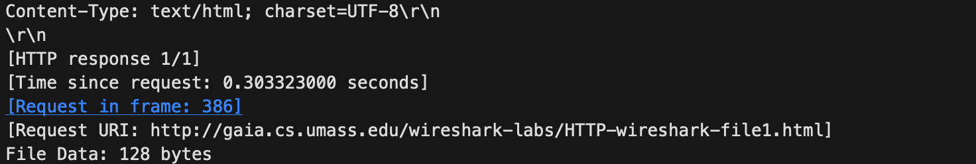

**Part 2:-**

1)

No, I did not see “IF-MODIFIED-SINCE” line in the HTTP GET

2)

Yes, initially the server did 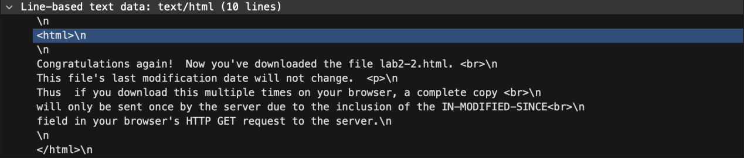explicitly return the contents of the file as follows:

3)

Yes, I see an “IF-MODIFIED-SINCE:” line in the HTTP GET.

**Tue, 16 Jan 2024 06:59:02 GMT\r\n** follows the respective header.

4)

Status code 304 status code is returned from the server in response to this second

HTTP GET.  
No, the server did not explicitly return the contents of the file since the IF-MODIFIED-SINCE time is same as the time for last modified in the previous request. Since, nothing was modified in the previous sent file, no new content was received.

**Part 3:-**

1)

**Part 4:-**

**Part 5:-**